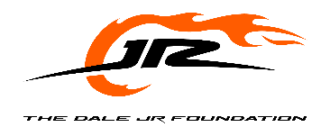
The Dale Jr. Foundation is a charity dedicated to giving underprivileged individuals with a focus on youth, the resources to improve their confidence and education, and the opportunity to achieve extraordinary goals.

2026 In-Kind Donation Request Form

Organization Information
Date of Request:*
*Date of request must be 8-12 weeks prior to event.

Organization Name:
Mailing Address (No P.O. Boxes Please):
City: State: Zip:
Telephone: Fax:
Website:
Contact Person: Title:
Phone: E-mail:

Tax Status
Tax Status (check one) 501(c)(3) Other
Include cover letter on organization letterhead and submit copy of 501(c)(3) letter
Legal Name, per IRS determination:
Tax ID # Date of IRS Letter:

Organization Mission
Brief Statement of organization’s objectives and/or activities:

Summary of Request:
Does this request fall within The Dale Jr. Foundation mission? Yes No
Type of Request: Auction or Raffle Item Event Sponsor
Event Name/Program Title:
Event Beneficiary (if different from requesting organization)
Purpose of Event/Program:
Event Location/Date/Time: Approximate Number of Attendees:
Describe use of item (auction, raffle, door prize, etc.)
Fundraising Goal for Event:

