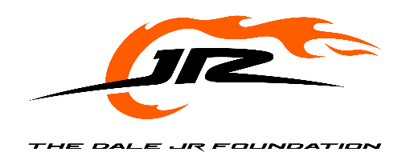
The Dale Jr. Foundation In-Kind Donation Guidelines
Mission Statement: The Dale Jr. Foundation is a charity dedicated to giving underprivileged individuals, with a focus on youth, the resources to improve their confidence and education, and the opportunity to achieve extraordinary goals.
Geographic Focus: While The Dale Jr. Foundation proudly supports organizations across the United States, the majority of our grantmaking is focused in North Carolina, where we strive to make the greatest local impact. A limited number of grants may be awarded to organizations located in other states that align closely with our mission and areas of giving.
Areas of Giving: The mission of the grantee and the grant requests must primarily align with at least one of the Foundation’s five key areas of giving with a focus on youth:
Hope – Programs that inspire optimism and resilience in the face of adversity.
Hunger – Initiatives that address food insecurity and provide access to nutritious meals.
Education – Efforts that support academic achievement, literacy, and access to learning resources.
Wellness – Programs that promote physical, emotional, or mental well-being.
Empowerment – Initiatives that equip individuals, particularly youth, with the tools and confidence to reach their full potential.
Eligibility Requirements: To be eligible for consideration, organizations must meet the following criteria:
- Must be a 501(c)(3) nonprofit organization in good standing. The organization must be in compliance with all state and federal guidelines and adhere to best practices for non-profit organizations.
- Must operate programs that primarily align with and fit at least one of the Foundation’s five areas of giving with a focus on underprivileged youth with a creative, substantive approach to meet critical needs and/or important emerging issues.

Application Process:
- Submit an In-Kind Donation Application. Applications can be found on The Dale Jr. Foundation website and may be submitted via emailed to tdjf@dalejr.com.
- Provide the following attachments:
  - Cover letter on organization letterhead
  - Event marketing materials
  - IRS 501(c)(3) determination letter
Overall Discretion: The Board of Directors of The Dale Jr. Foundation retains the power, authority and sole discretion on the applicability of these guidelines and the ultimate grant making process.

